An Internship Report
Of

Data Science Master Virtual Internship

Submitted
To

School of Computer Science and Engineering
IILM University, Greater Noida, U.P.

In partial fulfilment of the requirement of degree of
B-Tech (CSE)



By

Roll Number of Student:- 2410030671
Name of Student: ADITI PANDEY
Batch: 2024-28

CANDIDATE'S DECLARATION
I, ADITI PANDEY, do hereby declare that the internship report titled “Data Science Master Virtual Internship” has been completed by me to fulfil the requirement for the award of the degree of Bachelor of Technology in Computer Science and Engineering. All the references have been quoted and I have not taken as such any material from any other source. I affirm that this report is my own and has not been submitted to any other institute for any degree/diploma requirement, and further I shall be solely responsible for any kind of copyright violation in this regard.

Student Name: ADITI PANDEY
Roll No.: 2410030671

ACKNOWLEDGEMENT
I am using this opportunity to express my gratitude to everyone who supported me throughout the Internship Program. I am thankful for their aspiring guidance, invaluably constructive criticism and friendly advice during this work. I am sincerely grateful to them for sharing their truthful and illuminating views on a number of issues related to this work.
I would like to thank the AICTE – National Internship Portal Virtual Internship Program team and EduSkills Academy for providing me the opportunity and the structured platform to learn and gain hands-on exposure in the domain of Data Science. I am also grateful to Siemens for supporting this programme and enriching it with industry-relevant learning. I am also thankful to my institute, IILM University, Greater Noida, and the faculty of the School of Computer Science and Engineering for their continuous support and encouragement.
I express my gratitude to my parents for their blessings.

Student Name: ADITI PANDEY
Roll No.: 2410030671

TABLE OF CONTENTS
1. Candidate's Declaration i
2. Acknowledgement ii
3. Internship Completion Certificate -
4. Project Description 1
4.1 Introduction 1
4.2 Organization Profile 2
4.3 Problem Statement 3
4.4 Project Objectives 3
4.5 Scope of the Project 4
4.6 Technologies and Tools Used 4
4.7 Data Science Workflow 5
4.8 Methodology 6
4.9 Expected Outcomes 7
4.10 Certificates of Completion and Communication Proof 8
5. Bibliography/References 9

Internship Offer Letter

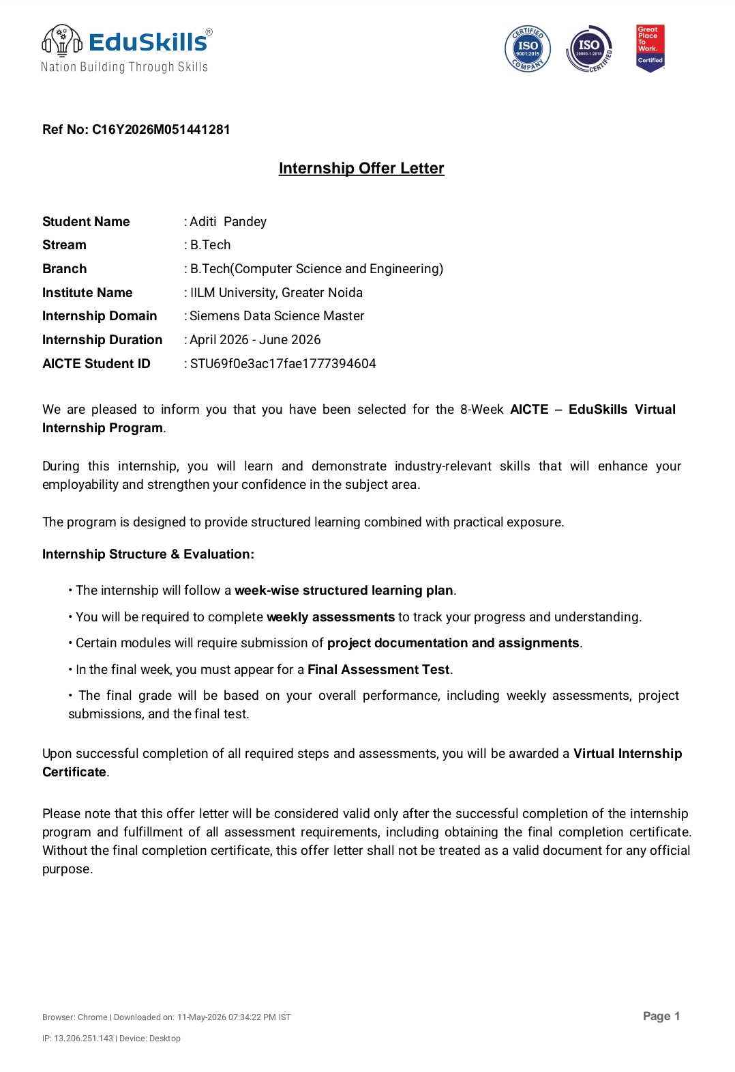

3. INTERNSHIP COMPLETION CERTIFICATE
The Certificate of Virtual Internship issued to Aditi Pandey by the AICTE – National Internship Portal and EduSkills, in association with Siemens, on successful completion of the 8-week Data Science Master Virtual Internship (April – June 2026), is presented below.
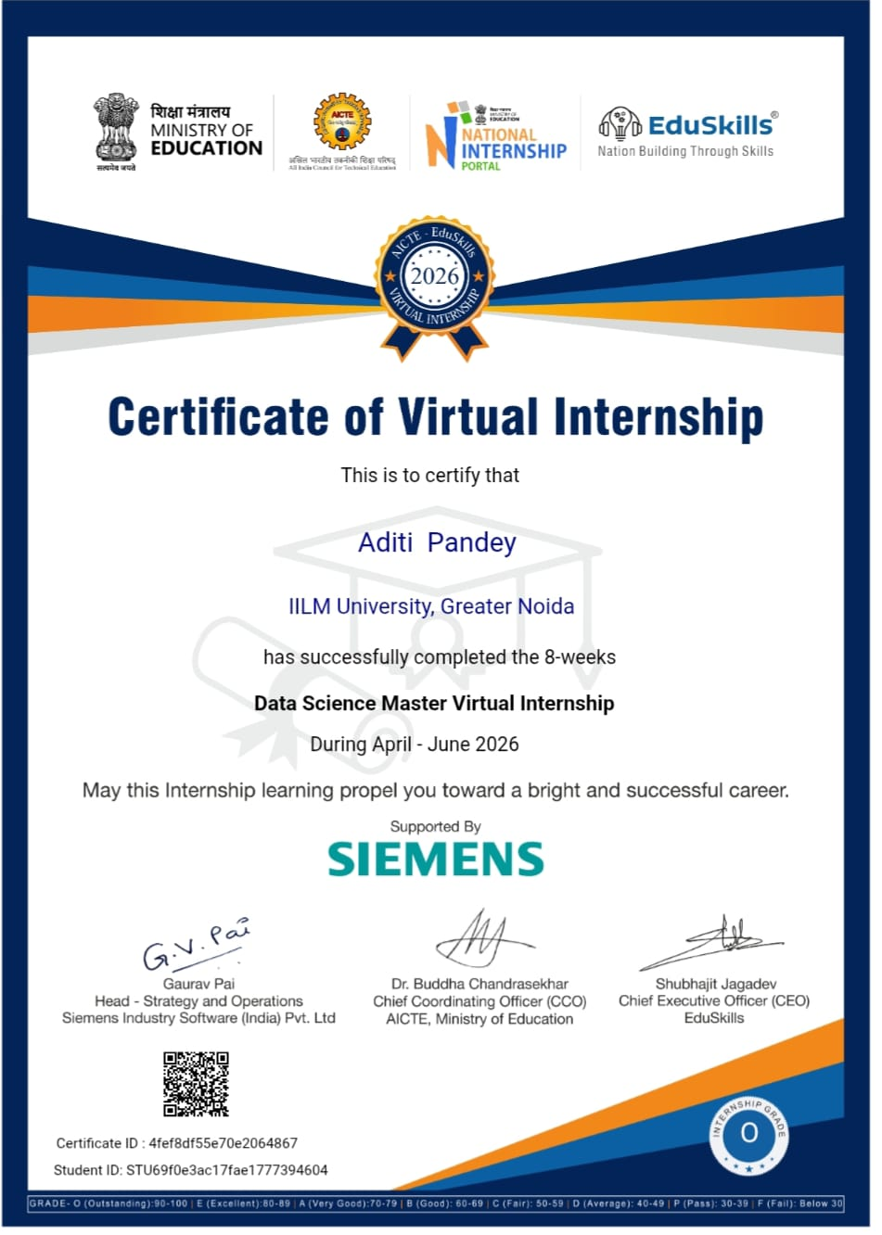

4. PROJECT DESCRIPTION

4.1 Introduction
This report presents a detailed account of the 8-week Virtual Internship undertaken under the AICTE – National Internship Portal Virtual Internship Program, in the domain of “Data Science”, offered through the Data Science Master Virtual Internship. The internship was carried out from April 2026 to June 2026 as part of the requirement of the Bachelor of Technology (Computer Science and Engineering) programme at IILM University, Greater Noida. The primary aim of this internship was to bridge the gap between theoretical understanding of statistics, programming, and machine learning, and their real-world application in analysing data and building data-driven solutions. Over the course of the programme, the learner was exposed to industry-relevant tools and practices used to collect, clean, explore, visualize, and model data in order to generate actionable business insights.
The internship followed a structured, week-wise curriculum that combined conceptual learning with hands-on assignments, weekly assessments, project documentation, and a final capstone project. On successful completion of all the requirements, including the final assessment test, a Virtual Internship Certificate with an Outstanding (O) grade was awarded, supported by Siemens.

4.2 Organization Profile
The internship was delivered under the AICTE National Internship Portal in association with EduSkills, an organization working under the theme “Nation Building Through Skills”. EduSkills partners with the All India Council for Technical Education (AICTE) to run structured virtual internship programmes for engineering students across the country. The Data Science Master Virtual Internship was supported by Siemens, a global technology company, which helped enrich the curriculum with industry-aligned use cases and practical relevance. Together, these organizations collaborate with academic institutions to design internship curricula that help students strengthen their employability and gain practical exposure to emerging technology domains such as Data Science, Artificial Intelligence, and Analytics.

4.3 Problem Statement
Although a large number of engineering students learn programming and mathematics during their academic coursework, very few get exposure to the practices required to work with real, messy data and turn it into meaningful insight. Knowing how to code is only one part of Data Science; being able to collect, clean, explore, analyse, visualize, and model data to answer a real business question is an equally important and often overlooked skill. The problem addressed by this internship was to understand and practically implement the complete Data Science workflow – from raw, unstructured data to statistical analysis, visual storytelling, machine learning models, and finally, actionable insights that could support real decision-making.

4.4 Project Objectives
- To understand the complete Data Science lifecycle and the terminology used in the industry.
- To build strong Python programming foundations for reading, cleaning, and manipulating data.
- To learn statistics and probability concepts essential for analysing and interpreting data.
- To gain hands-on experience with SQL for storing, querying, and extracting data from databases.
- To learn data visualization techniques using tools such as Matplotlib, Seaborn, and Power BI/Tableau.
- To understand the fundamentals of Machine Learning, including supervised and unsupervised learning.
- To build, evaluate, and improve basic Machine Learning models using real-world datasets.
- To apply all the above concepts to real, industry-inspired case studies drawn from Siemens' domain of work.
- To apply all the above concepts in a real-world, end-to-end capstone project.

4.5 Scope of the Project
The scope of this internship spans the entire Data Science pipeline – starting from collecting and cleaning raw data, performing exploratory data analysis, applying statistical techniques, visualizing findings through charts and dashboards, and finally building and evaluating Machine Learning models. It also covers the application of these techniques to real-world, industry-style business problems inspired by Siemens' operations. The internship was limited to a virtual, simulation/lab-based environment provided through the AICTE – National Internship Portal and EduSkills, and did not involve deployment on any live organizational production system.

4.6 Technologies and Tools Used
Category | Technologies / Tools
Programming Language | Python
Data Handling | Pandas, NumPy, SQL
Data Visualization | Matplotlib, Seaborn, Power BI / Tableau
Machine Learning | Scikit-learn
Development Environment | Jupyter Notebook
Productivity Tools | Microsoft Excel

4.7 Data Science Workflow
The general workflow followed during the internship for solving a data science problem can be summarized in the following layers:
- Data Collection Layer: Raw data is gathered from files, databases, or simulated real-world sources.
- Data Cleaning & Preprocessing Layer: Missing values, duplicates, and inconsistencies are handled using Python and Pandas.
- Exploratory Data Analysis (EDA) Layer: The data is explored to understand patterns, trends, and relationships between variables.
- Statistical Analysis Layer: Descriptive and inferential statistics are applied to summarize and draw conclusions from the data.
- Visualization Layer: Findings are communicated through charts and dashboards using Matplotlib, Seaborn, and Power BI/Tableau.
- Model Building Layer: Machine Learning algorithms are applied to build predictive or classification models using Scikit-learn.
- Model Evaluation Layer: Model performance is measured and improved using appropriate evaluation metrics.
- Insight & Reporting Layer: Final insights and model outputs are compiled into reports and dashboards for decision-making.

4.8 Methodology
The internship followed a structured, week-wise methodology combining conceptual learning, hands-on labs, weekly assessments, and project submissions, as summarized in the table below.
Week | Module | Description
1 | Introduction to Data Science & Python Foundations | Overview of the Data Science lifecycle, industry landscape, environment setup, and Python programming basics for working with data.
2 | Statistics & Probability for Data Science | Descriptive and inferential statistics, probability distributions, and hypothesis testing as applied to real datasets.
3 | Data Wrangling & SQL | Cleaning messy, real-world data, handling missing values and duplicates, and writing SQL queries to extract and join data.
4 | Exploratory Data Analysis & Data Visualization | EDA techniques, chart-based storytelling with Matplotlib and Seaborn, and dashboard building using Power BI/Tableau.
5 | Machine Learning Fundamentals | Introduction to supervised and unsupervised learning, and the basics of regression and classification.
6 | Building & Evaluating Machine Learning Models | Training models with Scikit-learn, evaluating performance using accuracy, precision, recall and related metrics, and basic feature engineering.
7 | Real Industry Case Studies | Applying the Data Science workflow to real-world, industry-style business problems inspired by Siemens' domain of work.
8 | Capstone Project & Final Assessment | An end-to-end capstone project covering data collection through to insight generation, followed by a Final Assessment Test.

Each week concluded with a weekly assessment to evaluate conceptual understanding, and selected modules required submission of project documentation and assignments. In the final week, a Final Assessment Test was conducted, and the overall grade – an Outstanding (O) grade in this case – was based on performance across weekly assessments, project submissions, and the final test.

4.9 Expected Outcomes
- Ability to independently collect, clean, and prepare raw data for analysis using Python and SQL.
- Practical understanding of statistics and probability as applied to real datasets.
- Skill to explore data and communicate findings through charts and dashboards.
- Capability to build and evaluate basic Machine Learning models on real-world data.
- Understanding of how Data Science techniques are applied to real, industry-style business problems.
- A completed, end-to-end capstone project demonstrating the full Data Science workflow, from raw data to actionable insight.

4.10 Certificates of Completion and Communication Proof
The Certificate of Virtual Internship issued to Aditi Pandey, confirming successful completion of the 8-week Data Science Master Virtual Internship (April – June 2026) with an Outstanding (O) grade, awarded through the AICTE – National Internship Portal and EduSkills, and supported by Siemens, is attached in Chapter 3 of this report.

5. BIBLIOGRAPHY/REFERENCES
1. AICTE – National Internship Portal & EduSkills, “Data Science Master Virtual Internship,” Certificate of Virtual Internship, Certificate ID: 4fef8df55e70e2064867, 2026.
2. IILM University, Greater Noida, Student ID: STU69f0e3ac17fae1777394604, 2026.
3. Python Software Foundation, Python Documentation, https://docs.python.org/
4. Pandas Documentation, https://pandas.pydata.org/docs/
5. NumPy Documentation, https://numpy.org/doc/
6. Scikit-learn Documentation, https://scikit-learn.org/stable/
7. Matplotlib and Seaborn Documentation, https://matplotlib.org/ , https://seaborn.pydata.org/
8. Microsoft Power BI and Tableau official documentation.
9. Siemens – official website, https://www.siemens.com/

